**Case Study :**

**• Apple Brand :**

**Apple Inc.** (formerly **Apple Computer, Inc.**) is an American [multinational](https://en.m.wikipedia.org/wiki/Multinational_corporation) technology [company](https://en.m.wikipedia.org/wiki/Company) headquartered in [Cupertino, California](https://en.m.wikipedia.org/wiki/Cupertino,_California), in [Silicon Valley](https://en.m.wikipedia.org/wiki/Silicon_Valley). It designs, develops, and sells [consumer electronics](https://en.m.wikipedia.org/wiki/Consumer_electronics), [computer software](https://en.m.wikipedia.org/wiki/Computer_software), and [online services](https://en.m.wikipedia.org/wiki/Online_service). Devices include the [iPhone](https://en.m.wikipedia.org/wiki/IPhone), [iPad](https://en.m.wikipedia.org/wiki/IPad), [Mac](https://en.m.wikipedia.org/wiki/Mac_(computer)), [Apple Watch](https://en.m.wikipedia.org/wiki/Apple_Watch), and [Apple TV](https://en.m.wikipedia.org/wiki/Apple_TV); [operating systems](https://en.m.wikipedia.org/wiki/Operating_systems) include [iOS](https://en.m.wikipedia.org/wiki/IOS) and [macOS](https://en.m.wikipedia.org/wiki/MacOS" \o "MacOS); and software applications and services include [iTunes](https://en.m.wikipedia.org/wiki/ITunes), [iCloud](https://en.m.wikipedia.org/wiki/ICloud), and [Apple Music](https://en.m.wikipedia.org/wiki/Apple_Music).

**• The Latest Campaigns of Apple :**

Apple is known for its innovative and sleek marketing campaigns. Some of their notable campaigns include "Think Different," emphasizing creativity and individuality, and more recently, the "Shot on iPhone" campaign showcasing the capabilities of their camera technology. Apple consistently focuses on design, simplicity, and user experience in their advertising. For the latest campaigns, visit Apple's official website or follow recent marketing updates.

**1.”Think Different “ Campaign:**

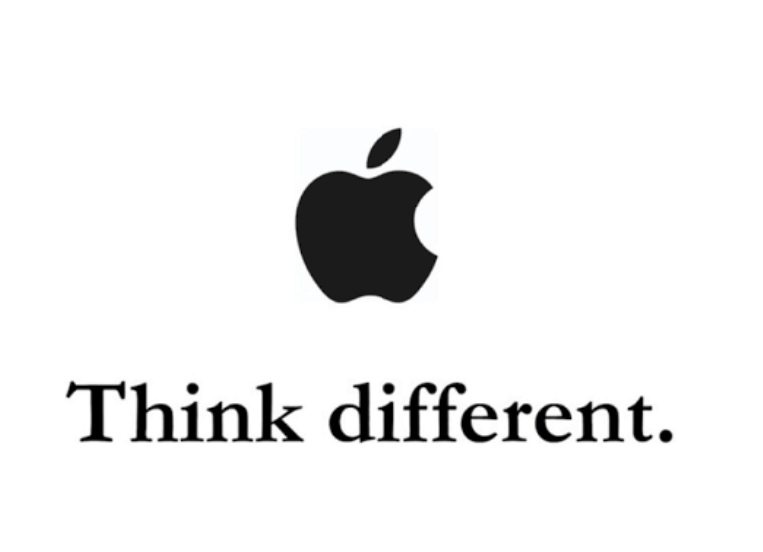The "Think Different" campaign by Apple was launched in 1997 and continued until 2002. It celebrated notable figures who challenged the status quo, encouraging people to embrace innovation and individuality. The iconic ad featured black-and-white images of historical figures like Albert Einstein, Martin Luther King Jr., and Mahatma Gandhi, accompanied by the tagline "Think Different." This campaign aimed to associate Apple products with a spirit of creativity, innovation, and non-conformity.

**2. 1984- Macintosh launch campaign :**

The 1984 Macintosh launch campaign is iconic in advertising history. Apple’s Super Bowl XVIII commercial, directed by Ridley Scott, depicted a dystopian future inspired by George Orwell’s novel “1984.” It introduced the Macintosh as a revolutionary product, challenging the dominance of IBM. The ad concluded with the tagline “On January 24th, Apple Computer will introduce Macintosh. And you’ll see why 1984 won’t be like ‘1984.’” The campaign was bold, innovative, and is often considered a watershed moment in marketing.

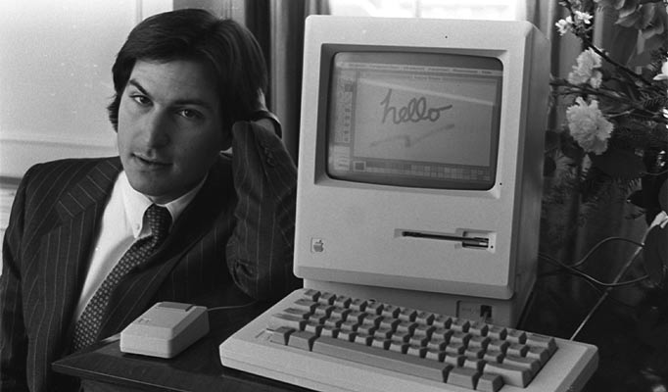

**3.”Get Mac” campaign:**

Get a Mac (2006-2009): Featuring John Hodgman as PC and Justin Long as Mac, this campaign humorously compared the two platforms to highlight Mac's advantages.

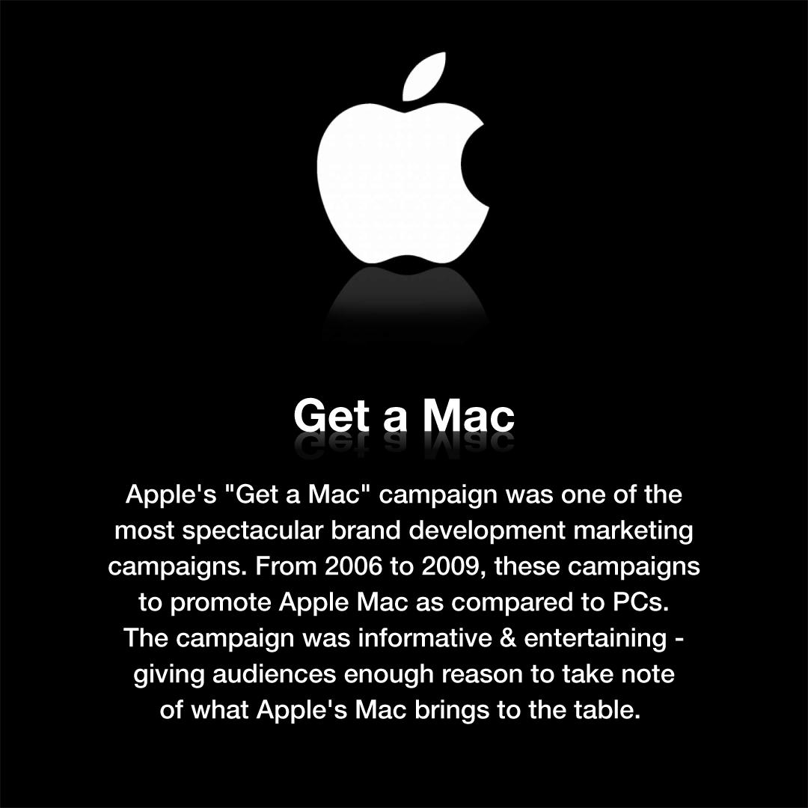

Silhouette iPod Ads (2003-2008): Set to catchy music, these ads showcased people dancing with iPods in silhouette, emphasizing the joy of music.

**4.”Shot on iPhone”Campaign :**

The "Shot on iPhone" campaign by Apple showcases photos and videos taken by iPhone users, highlighting the device's camera capabilities. It emphasizes the quality and creativity achievable with iPhone cameras, featuring user-generated content in various marketing materials.

Apple will film something with a billion dollar gimbal and an unlimited lighting budget and yall are shocked to see when it says ‘Shot on iPhone.’ Yes it was shot on iPhone but you, [an average and poor consumer will never be able to recreate what they did](https://twitter.com/jeremyjudkins_/status/1719329549945590124).”

"Shot on iPhone" is a marketing campaign by Apple showcasing the photographic capabilities of the iPhone. It features photos and videos taken by iPhone users worldwide.

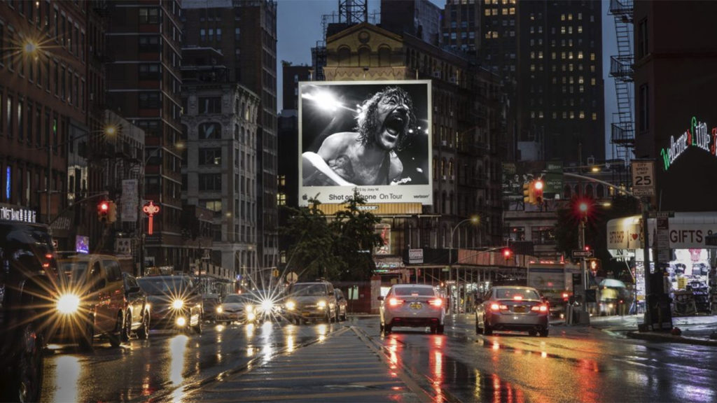

**5.”Silhourette ipod ads”campaingn :**

The iconic iPod silhouette ads by Apple featured colorful silhouettes of people dancing with iPods and white earphones, highlighting the device's music capabilities. These ads were part of Apple's successful marketing campaign that helped establish the iPod as a cultural phenomenon

. The iPod ads, particularly the "silhouette" campaign, were launched by Apple in the early 2000s.These ads featured vibrant, solid-colored backgrounds with black silhouettes of people dancing or engaging in various activities while listening to music on their iPods. reativity and played a significant role in establishing the iPod as a cultural icon and a market leader in portable music players.

